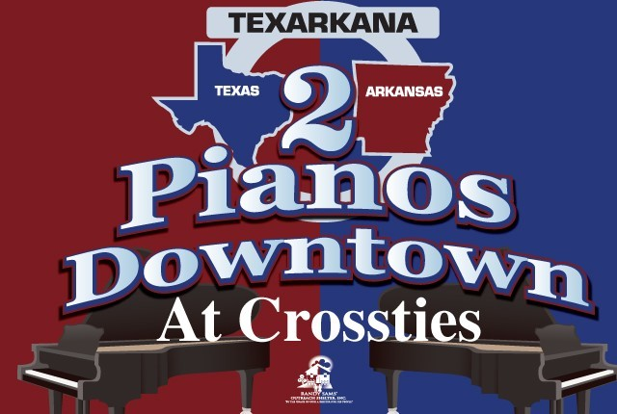

Randy Sams Outreach Shelter looks forward to hosting our “2 Pianos Downtown”
6:30 PM on April 16, 2026
Crossties Event Venue
- $10,000 Grand Piano Level -24 tickets and media recognition plus reserved tables at the event.
- $7,500 Piano Level -16 tickets and media recognition plus reserved tables at the event.
- $5,000 Cuban Level -12 tickets and media recognition plus reserved tables at the event.
- $2,500 Cosmopolitan Level – 8 tickets and media recognition plus reserved table at the event.
- $1,000 Stage level – 6 tickets and media recognition.
- $500 Saxophone Level – 4 tickets and media recognition.
- $250 Dirty Martini Level - 2 tickets and media recognition.
- Please make checks payable to the Randy Sams Outreach Shelter and send to:
Randy Sams Outreach Shelter The number of tickets you plan to use _______
803 Spruce St. (This helps us plan for food)

Texarkana, Texas 75501
- Or use the QR Code to pay for your sponsorship
- Check here if you wish to be invoiced for your Sponsorship
- I am unable to attend but enclosed is a donation.

Name:
Address:
City, ST, Zip:
Phone #:
Email:
Name as you wish it to appear in acknowledgement

Randy Sams Outreach Tax ID Number: 75-2627181
As a 501(c)3 non-profit, all donations are tax-deductible to the extent allowed by law.

