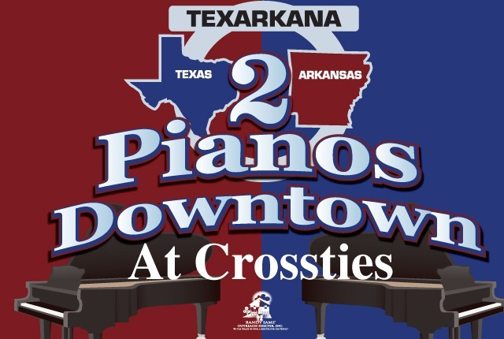

Randy Sams Outreach Shelter looks forward to hosting our “2 Pianos Downtown”
7:00 PM on April 24, 2025
Crossties Event Venue
- $5,000 Piano Level -16 tickets and media recognition plus reserved tables at the event.
- $3,000 Cuban Level -12 tickets and media recognition plus reserved tables at the event.
- $2,000 Cosmopolitan Level – 8 tickets and media recognition plus reserved table at the event.
- $1,500 Pearl Level - 8 tickets and media recognition.
- $1,000 Stage level – 6 tickets and media recognition.
- $500 Saxophone Level – 4 tickets and media recognition.
- $250 Dirty Martini Level - 2 tickets and media recognition.
- Please make checks payable to the Randy Sams Outreach Shelter and send to:
Randy Sams Outreach Shelter The number of tickets needed _______
803 Spruce St. (This helps us plan for food)
Texarkana, Texas 75501
- Check here if you wish to be invoiced for your pledge
- I am unable to attend but enclosed is a donation.

Name:
Address:
City, ST, Zip:
Phone #:
Email:
Name as you wish it to appear in acknowledgement

Randy Sams Outreach Tax ID Number: 75-2627181
As a 501(c)3 non-profit, all donations are tax-deductible to the extent allowed by law.

